Exercise 7: Handling errors

Objective
In an Express application, handling errors efficiently is crucial for maintaining a good user experience and simplifying debugging. Error handling typically involves catching errors when they occur and sending appropriate responses to the client. In this example, you'll learn how to handle errors that might occur when attempting to work with an "article" object, like trying to save it to a database.

Exercise
- Using node-express app in previous exercise
- In app.js file, write this code
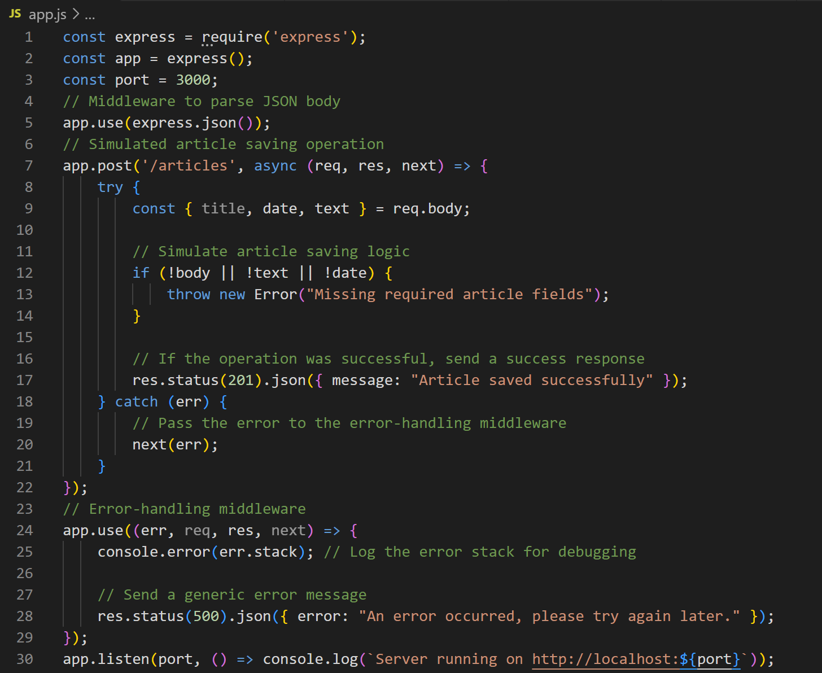
Error Propagation: By calling next(err), we pass the error to the next error-handling middleware in the stack. This allows centralized error handling.
Error-handling Middleware: The function with the signature (err, req, res, next) is designed to catch any errors passed via next(err). It's a good place to log errors and send a generic error response to the client.
- Test with Postman
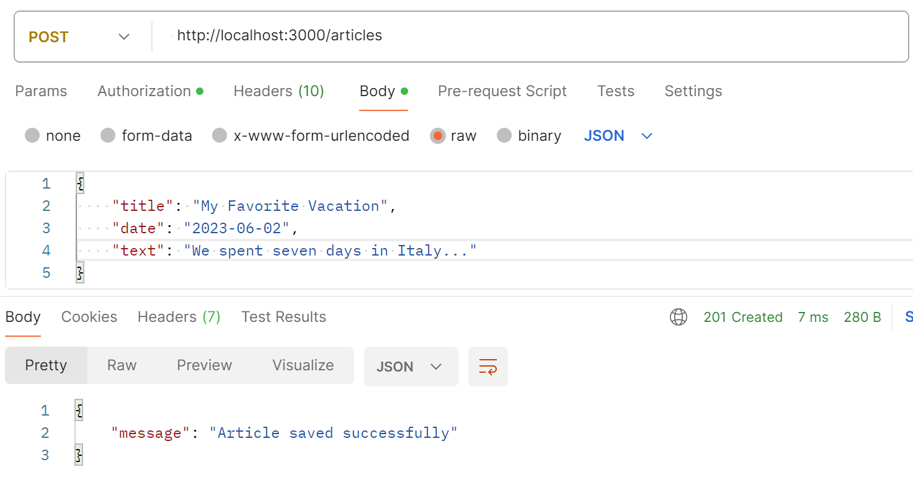
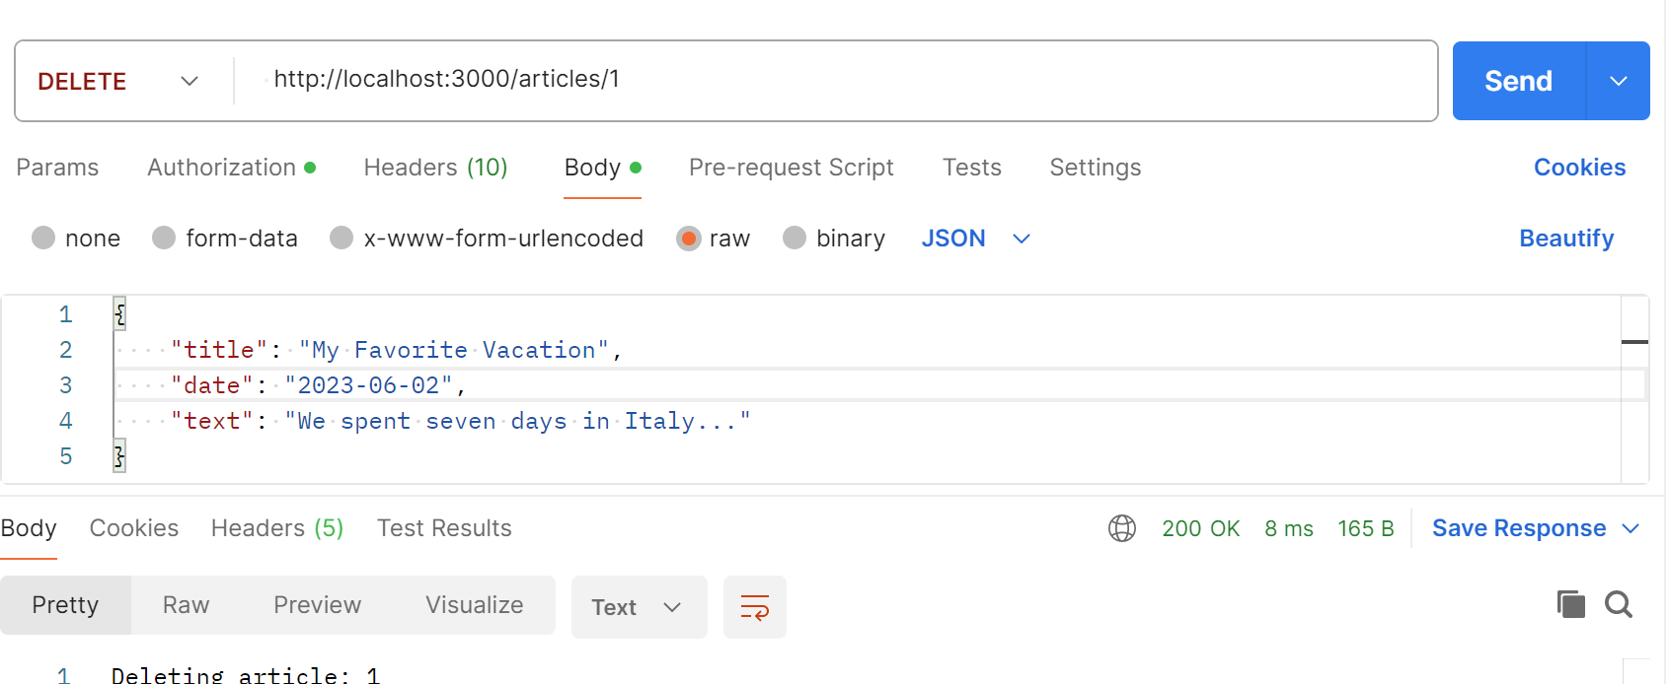

Exercise 2
- In node-express, add handling errors with articleRouter.js and videoRouter.js in routers folder
- Call it in app.js file and test with Postman

Conclusion
This exercise aims to deepen your understanding of how to create handling errors in separating routers with Express framework.

